Packet Tracer - Troubleshoot Connectivity Issues - Physical Mode

# Topology

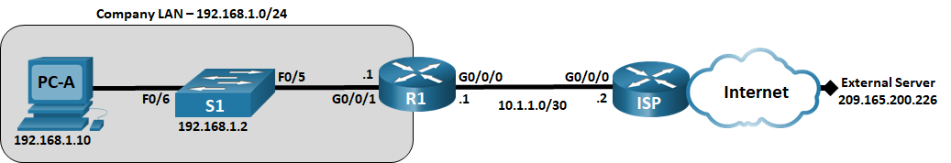

# Addressing Table

|  |  |  |  |  |
| --- | --- | --- | --- | --- |
| Device | Interface | IP Address | Subnet Mask | Default Gateway |
| R1 | G0/0/0/1 | 192.168.1.1 | 255.255.255.0 | N/A |
| R1 | G0/0/0 | 10.1.1.1 | 255.255.255.252 | N/A |
| ISP | G0/0/0 | 10.1.1.2 | 255.255.255.252 | N/A |
| ISP | Lo0 | 209.165.200.226 | 255.255.255.255 | N/A |
| S1 | VLAN 1 | 192.168.1.2 | 255.255.255.0 | 192.168.1.1 |
| PC-A | NIC | 192.168.1.10 | 255.255.255.0 | 192.168.1.1 |

Blank Line - no additional information

# Objectives

Part 1: Identify the Problem

Part 2: Implement Network Changes

Part 3: Verify Full Functionality

Part 4: Document Findings and Configuration Changes

# Background / Scenario

In this Packet Tracer Physical Mode (PTPM) activity, the company that you work for is experiencing problems with their LAN. You have been asked to troubleshoot and resolve the network issues. In Part 1, you will connect to devices on the LAN and use troubleshooting tools to identify the network issues, establish a theory of probable cause, and test that theory. In Part 2, you will establish a plan of action to resolve and implement a solution. In Part 3, you will verify that full functionality has been restored. Part 4 provides space for you to document your troubleshooting findings along with the configuration changes that you made to the LAN devices.

# Instructions

## Identify the Problem

The only available information about the network problem is that the users are experiencing slow response times and that they are not able to reach an external device on the internet at IP address 209.165.200.226. To determine probable cause(s) for these network issues, you will need to utilize network commands and tools on the LAN equipment.

**Note**: The username **admin01** with a password of **cisco12345** will be required to log on to the network equipment.

### Troubleshoot the network.

Use the tools available to you to troubleshoot the network, keeping in mind that the requirement is to restore connectivity to the external server and the eliminate slow response times.

### Document the probable causes.

List the probable causes for the network problems that employees are experiencing.-

-**The Default Gateway is not set on the PC.**

**-S1 Interface F0/5 is set to half duplex and speed set to 10.**

**-S1 default-gateway is set to 192.168.1.0**

**-R1 G0/0/1 is set to half duplex and the speed is set to 10.**

**-The gateway of last resort is not set on R1.**

Type your answer here.

## Implement Network Changes

You have communicated the problems that you discovered in Part 1 to your supervisor. She has approved these changes and has requested that you implement them.

## Verify Full Functionality

Verify that full functionality has been restored. PC-A, S1, and R1 should be able to reach the external server, and ping replies from PC-A to the external server should exhibit no significant variation in response times.

## Document Findings and Configuration Changes

Use the space provided below to document the issues found during your troubleshooting and the configurations changes made to resolve those issues.

**Devices R1 and S1 was configured and corrected,and some ports was shut.**

Type your answers here.

# Reflection Question

This Packet Tracer Lab Companion had you troubleshoot all devices before making any changes. Is there another way to apply the troubleshooting methodology?

**Another ways of troubleshooting may be configuring the basic device configurations before moving to another device .**

Type your answers here.

1. End of document

End of document